产品资料

1.产品名称：
2.简要介绍：
3.设备构成图片：
4.重要零部件图片及简介：
5.软件特性：
6.重要零部件介绍及参数：
7.内部结构要点介绍：
8.重要零部件介绍及参数：
9.产品应用领域介绍+图片+名称：
10.典型客户：
11.客户培训，装机，合同发货，付款，质保条款等：

1.产品名称：必要！
PCB LASER MARKING MACHINE
LCD Serie

2.简要介绍：必要！

PCB Laser Marking Machine from HGLASER is designed for bar codes marking, 2D codes and characters, graphics and other information on any kinds of printed circuit board. Integrated with high-performance CO2 / Fiber laser source, import high-pixel CCD camera and micron-level mobile module, PCB Laser Marking Series is competent to pre-marking automatic positioning and post-marking feedback reporting.

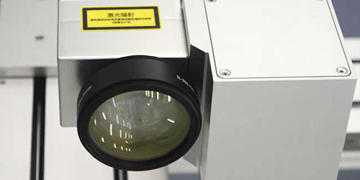
Fast Marking Speed

Professional industrial laser, fast marking speed, operated in 24 hours continuously, suitable for high-speed continuous production line

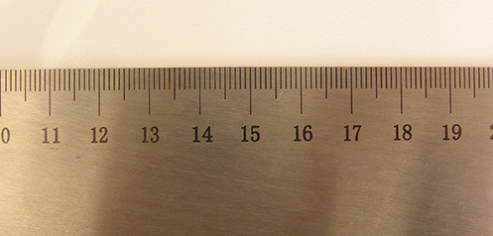

High Precision Marking

High-precision galvanometer scanning system, uniform light spot, precision marking, 100% positive feedback.

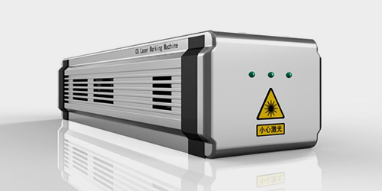
Low Energy Consumption
High electro-optic conversion efficiency, no consumables within 100,000 hours.

Flexible Structure
Friendly man-machine dialogue interface, easy operation and adjustment.

3.性能介绍：必要！

Main features of PCB laser marking machine:

1. High-quality laser beam, small focusing spots and well-distributed power.
2. High-pixel CCD camera makes automatic positioning, identification and feedback reporting come true.
3. Gantry structure and synchronous transmission guide ways ensure the stable & precision performance.
4. Automatic focusing and track width adjusting are designed to match up different production lines.
5. Integrated with SMT online operation and automatic off-board station.
6. Independent research on specialized software for PCB marking, with function of preventing and repairing, reducing the rate of product irregularity.
7. Connected with MES system for data communication

设备构成图片：必要！

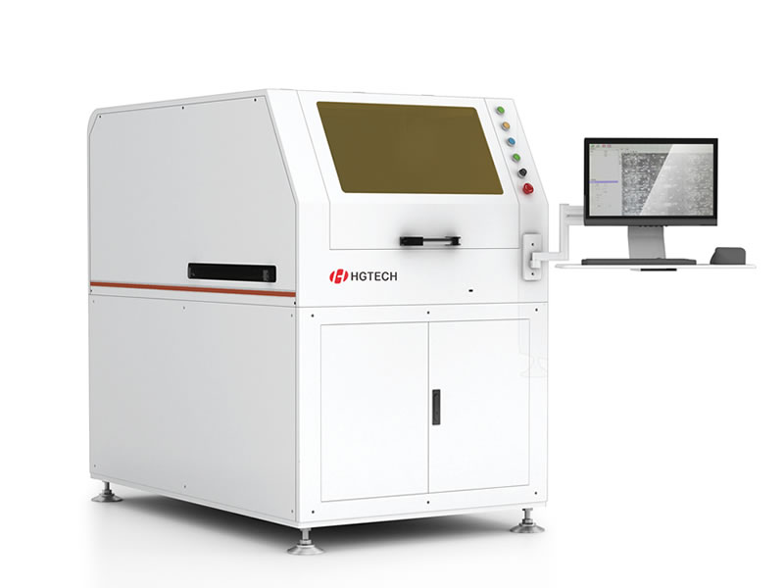

4.重要零部件图片及简介：必要！
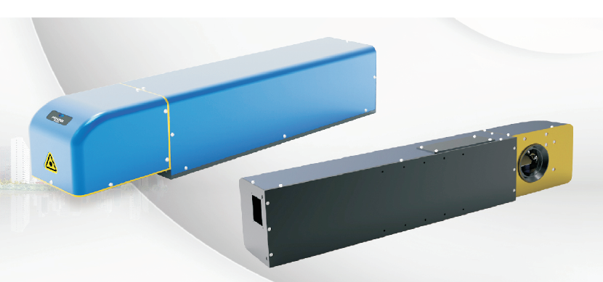
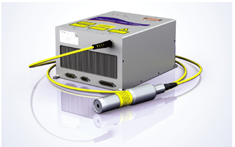

20/30/50W fiber laser
Cabinets and affiliated mechanisms
laser
Import components dynamic focusing system
laser

5.软件特性：

- Windows interface, all the Chinese/English-language operating system compatible with Photoshop, CORELDRAW, AutoCAD and other CAD software;
- Input: Chinese and English words, time, dates, barcodes, serial numbers and other markings(standard);
- Output: Chinese and English graphics, all types of barcodes, two-dimensional codes(standard);
- Advantages:
- 1) Marking software is using Visual Basic, users can take advantage of 32 technical, and marking software is running in Windows XP/7 system;
- 2) Marking speed twice faster than traditional methods;
- 3) Friendly interface: Marking software allows the user setting interface personalized, software can adapt to the individual requirement of user.

6.重要零部件介绍及参数：必要！

Laser marking machine is made up by laser, control box, focusing system and Computer.
The brief of the main parts are as followed:

Configuration
 | Parts | Description
Standard configuration | Laser Source | TOP GRADE IPG/Raycus 10/20/30/50W pulsed fiber laser source  Coherent or Synrad or Rofin 10/20/30/40W for CO2 laser source
 | Control box | Laser power
 | Cooling system | Air cooling
 | Scanner | China / German brand high speed
 | Focus lens | F=160mm，area 110mm×110mm（标准）
 | Marking software and computer | Processor 2.6G、memory≥2G、hardware≥500GB、17’LCD、SATA×2、 USB×8、COM×1、LDT×1、LAN×1,2×PCIe ,1× 8Channel I/O ,WINDOWS 7 (English version)；
 | Z axis system | Range 285mm

7.内部结构要点介绍：

- Laser
·1064nm fiber laser marker
Laser power 20/30/50W
·Power supply
0-20A continuous adjustable switch power
External power supply single phase 220V，Max power 1KW
- Optical system
·1064nm high galvanometer accuracy reflection, focused beam system
·Mirror: beam reflector five times before expanding
·Galvanometer
high-speed high-precision vibration lens
--- Scanner
Resolution 0.001 mm
Repeat precision 0.003mm
Linear scanning speed Max 7,000 mm / s depends on the material
--- F-θ lens
Wavelength 1064 nm
Work scope 600mm×600mm×80mm (standard)

- Computer and control system
Control system
PCI Bus DA Control Card / Interface
• Industrial Computer
Processor 1.6G、memory≥1G、, 220GB Hard Drive, 17 'LCD, Chinese/English Windows operating system;

- Marking software
Windows interface, all the Chinese/English-language operating system compatible with Photoshop, CORELDRAW, AutoCAD and other CAD software;
Input: Chinese and English words, time, dates, barcodes, serial numbers and other markings(standard);
Output: Chinese and English graphics, all types of barcodes, two-dimensional codes(standard);
Advantages:
1) Marking software is using Visual Basic, users can take advantage of 32 technical, and marking software is running in Windows XP/7 system;
2) Marking speed twice faster than traditional methods;
3) Friendly interface: Marking software allows the user setting interface personalized, software can adapt to the individual requirement of user.

8.产品技术参数：必要！

Technical parameters

Technical index |  | LCD 10/20/30/50
Laser source | Syntony type | Fiber /CO2
 | Wavelength | 1064nm (for fiber and CO2 laser source)
 | Output power | 10/20/30/50W (for fiber and CO2 laser source)
 | Q switch frequency | ≤200 kHz (for fiber and CO2 laser source)
Galvo head | Max speed | 7000mm/s
 | Distinguish ratio | 0.001mm
 | Repeatability | 0.003mm
Optical output characters | Marking range | F=160mm，area 110×110mm (Standard)
 | Min line width | 0.01mm
 | Min characters height | 0.2mm
Cooling system | Cooling system | Air cooling (Fiber or CO2)
Control System | Laser power supply | AC110-220V/50-60Hz
 | Working table Z axis range | 285mm
 | Max Output power | 1KW
 | Working Condition | 0~35°C，Humidity≤90% (for fiber and CO2 laser source)

9.产品应用领域介绍+图片+名称：必要！

Widely and perfectly suitable for Computer, Consumer Electronic Industry, Cell key-press, Precision instrument, and 3C electronic industry, etc.

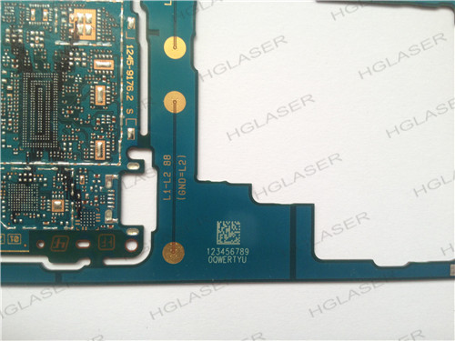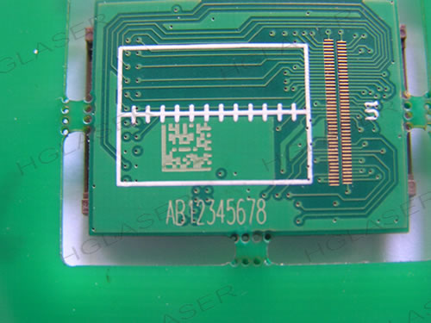
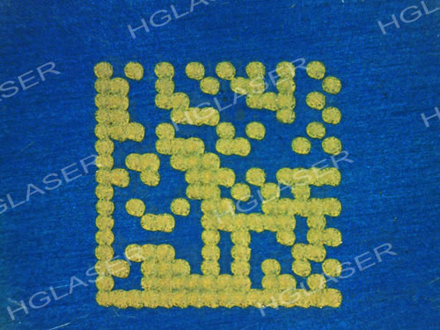

Training and Installation

After acceptance procedure completes, HG Laser will provide a 2-3 days training free of charge depends on the concrete situation, training content including:
- Basic knowledge of Laser security
- Introduction of principle of laser and structure of laser marking machine
- Operating with laser marking software
- Operating laser marking machine and notices
- Daily maintenance, alignment and spare-parts replacement

Every machine has completed installed, approved under extremely quality control system and performance test.
For complex machine or special request of customer, as soon as machine arrived, HG Laser will install the machine under assistance of customer, specialized tools and test equipment will be provided by HG Laser. Once again HG Laser will provide training to customer’s operators and relative staff.
Quality is our culture, excellent custom satisfaction is our soul!
Commissioning and Acceptance
At the completion of the installation, the commissioning will commence. The machine will be considered accepted once the machine completes acceptance tests to following standard. At the completion of commissioning training will commence.
No. | Items | Contents
1 | Time | After installation and commissioning
2 | Location | Customer's site
3 | Machine Appearance; Function Demonstration; Sample Marking | In accordance with technical proposal

Terms, Delivery and Payment
Please refer to quotation file, all payment are in US/Euro Dollars. Prices shown in the quotation supersede all previous offers, either written or verbal.
The quoted prices exclude any value added or goods and services tax. Such tax, if due, is payable by the customer on arrival of the machine at the port.
If, while on site, HG Laser technicians' schedule is delayed due to circumstances beyond their control, such as site not ready, service not ready, power failure, etc. Customer need to pay the time lost due to the delay at US$300/day/person extra cost.
This quotation is valid for 30 days from receipt of quotation. Prices will be held firm from date of order.
Please refer to the lead time at the third page that goes together with the quotation, based upon current work loading. Firm date will be organized upon receipt of order and deposit.
Delivery includes packing, insurance and freight from HGLaser’s store to customer’s premises. The customer must provide insurance, on the full value of the machine prior to unloading.
Delivery does not include unloading at customer site.
Payment terms lies as following:
- 30% Deposit with Order
- 70% Balance before the delivery /Upon shipping after completion of testing in our factory
Where the customer delays the delivery or commissioning, the payments will still be due on the dates these if actions would have taken place had there been no delay. Any expenses incurred as a result will be chargeable to the customer.
Warranty
Machine hardware is guaranteed from time of commissioning for a period of 12 months or 2000 hours whichever comes first. This guarantee covers all parts and labor under normal and proper use. The delivery of new parts is at Customer’s expense. Customers are expected to perform simple replacements to ensure minimum possible downtime.
This warranty does not cover compensation for loss of profit, loss of production or for any damage incurred by misuse.
Due to continual improvements in performance and/or manufacturing techniques, HG Laser reserves the right to make any design changes in the machine, or machine control equipment, program systems hardware or software.

