More Efficient FPC Laser Cutting on Your Production Line
Key words: FPC laser cutting, precise UV laser cutting, efficient PCB laser cutting
Equipped with international advanced UV laser devices, FPC laser cutting machine LBA15U from HGLASER is competent for higher efficiency and stability under high repeated power. Its precision and high energy laser beam can avoid burrs, deformation or damage to components when laser cutting thin plate.
It will fully meet the demand of more rational structure including camera module and fingerprint identification module, with granite cutting workstation, linear motor in high precision.The maximum processing size will be 300*400mm. It’s suitable for the cutting of common thin PCB, FR4,FPC, cover film, etc.

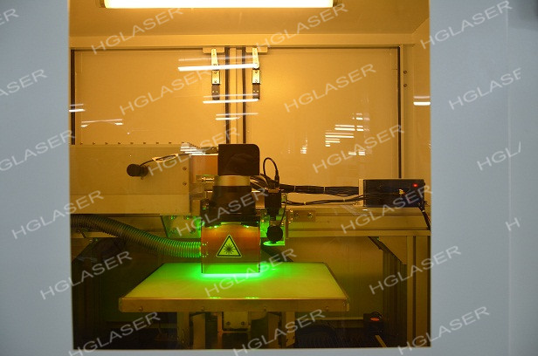

FPC Laser Cutting Machine LBA15U

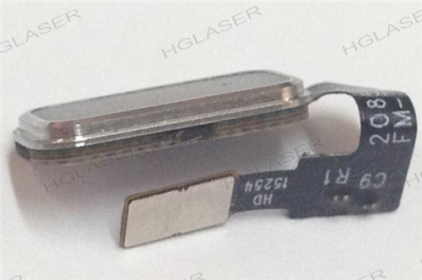
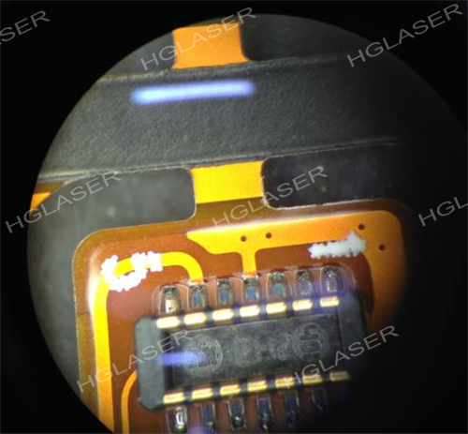

Precision Cutting
You can get leading performance for its stitching precision, repeated cutting and CCD matching precision under our professional equipment commissioning, with as precise as 20um cutting precision. The cutting effect of FPC Laser Cutting Machine has passed strict CPK size test.

Exquisite Shaping
FPC Laser Cutting Machine enjoys smaller focal spot and cutting width in balanced power distribution, for its customized optical system. With such great performance, you can get a perfect kerf with any possible carbonization invisible to the naked eye.
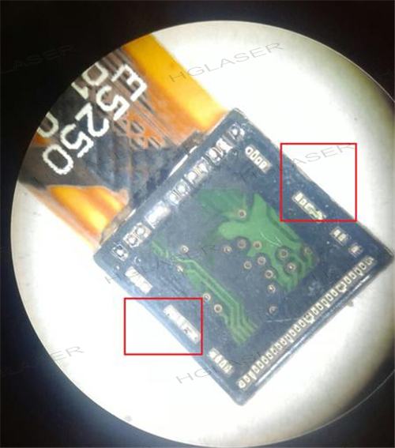
High Speed Cutting
We have managed parameter database for better and quicker to get perfect cutting pieces according to different laser cutting requirement. The “one key start” design and automatic identification function will simplify your processing. What’s more, the easy performance and installation will destress the repeated transformation of production lines
For laser marking customization, contact us by email info@hglaser.com or call us at
+86 27 8718 0225.

