Oil Slotted Casing Tube Laser Cutting Machine

Oil slotting pipe is the key part to protect from sand during oil mining. Oil slotting pipe can be classified into five types: bridge type oil slotting pipe, drilling slotting pipe, kerf slotting pipe, composted pipe, wire-wrapped slotting pipe. Oil slotted casing pipe is cut by specialized ultra-thin cutting disk and laser beam. There are many certain configurations kerfs with shape of longitudinal or helical straight line on oil slotted casing pipe.

Farley Laserlab oil slotting pipe laser cutting machine adopts advanced technology, which can cut different type of oil slotting pipe. By means of focusing, high density and high-power laser beam working on sieve pipe, on the premise of exceeding a threshold value of laser power density, heat energy from working gas and laser beam’s chemical reaction is absorbed by material, thus causing a dramatic increase in the temperature of laser sport on the surface of the casing, partial melting or gasification of workpiece material to form a hole, then relative motion of the casing and laser beam can achieve casing cutting. >> more
Mechanical Motion System
1. Cantilever Structure Technology (patent number: ZL 200520099443.7) provides open operation platform with one-time processing area of 12m x 1.5m;
2. Machine tool structure is composed of a bed, cantilever beam, special clamp for sieve pipe cutting, high precision ball screw lubrication device.
3. Customized cutting rotation axis, double chuck structure and variable pitch worm can fix sieve pipe more stable and much easier to cut oil pipes. Plane working table can also be equipped to cut plates.

Features
1. The slotted liner is a robust and cost-effective solution for long completions or low productivity wells;
2. We offer straight and keystone slot in a wide range of slotting patterns to satisfy the required open area;
3. High rigidity, resisting scrape and abrasion, high intensity, anti-corrosion and even distribution.

Rotation Axis
1. Support position adjusted according to the pipe diameter;
2. Max. pipe Length: 12m Max. pipe diameter: 240mm;
3. Rotating clamp adopt double chuck structure to avoid the pipe not being vertical and thermal deformation in processing;
4. Varying pitch worm gear is adopted to effectively achieve mechanical wear compensation.

Cutting Head and Nozzle
1. Customized Bifocal Laser Head (5" and 7.5"), convenient to change to cut material of different depth;
2. Laser head can detect pipe on-contact before cutting and automatically position when cutting to match position change;
3. Anti-collision all-around auto reset cutting head.

Oil Slotting Pipe Laser Cutting Machine

Brief Introduction Of Oil Slotting Pipe
Oil slotting pipe is the key part to protect from sand during oil mining. Oil slotting pipe can be classified into five types: bridge type oil slotting pipe, drilling slotting pipe, kerf slotting pipe, composted pipe,wire-wrapped slotting pipe. Oil slotted casing pipe is cut by specialized ultra-thin cutting disk and laser beam. There are many certain configurations kerfs with shape of longitudinal or helical straight line on oil slotted casing pipe.

Characters:
1. Qualified oil slotting pipe has smooth and uniform kerf, which has no burr situation and has good perpendicularity.
2. As oil slotting pipe is processed by oil casing, it is hard to be out of shape.
3. Oil slotting pipe has long life. As oil slotting pipe has been antiseptic treated, it has good anti-abrasive performance.
4. Oil slotting pipe has twice time open area than the same configuration oil pipe, so it is more convenient for liquid flowing in slotting pipe
5. Oil slotting pipe can protect from sand which has diameter larger than 0.3mm
6. Oil slotting pipe can be used in horizontal well and deviated well.
7. Oil slotting pipe can be equipped in string type, it is very convenient and easy to operate.

Technical Parameters:
1. pipe Types: Oil slotted casing pipe
2. pipe length: Max. 12m
3. Wall thickness: Max.20mm
4. pipe diameter: 50mm to 210mm for pipe less than 12m
5. Kerf Quantity: Any
6. Kerf width: (0.18-6mm)±0.03mm
7. Kerf type: Parallel, crisscross, spiral

Brief Introduction of Laser Processing for Oil Casing Tube
Advantages of Laser Processing for Oil Casing Tube
1. High precision: positioning precision is 0.05mm, repeated positioning accuracy is 0.02mm.
2.Narrow kerf: laser beam can be focused to a tiny light-spot, so that focus place has high power density, material will be heated quickly to gasification degree and vaporized to hole. As the relative linear movement of beam and material, the continuous hole will generate narrow kerf. the cutting edge width is generally 0.1mm to 0.2mm.
3.Cutting surface is smooth: no burr in cutting surface, cutting surface roughness is controlled within Ra12.5.
4.High speed: cutting speed can reach 10m/min, the maximum positioning speed can reach 200m/min, which is faster then linear cutting.
5.Excellent cutting quality: non-touch cutting, cutting edge has small thermal effect, workpiece has small thermal deformation, avoid tuned-down edge, kerf needn’t twice processing.
6.No damage to workpiece: laser cutting head will not touch material surface, no scratch to workpiece.
7.Not depends on material hardness: laser can process steel plate, stainless steel, aluminum alloy plate, hard alloy. No matter how hard the material is, it can cut without deformation.
8.Good flexibility:Laser cutting has good flexibility, it can process different figures, it can cut pipe or other profiled material.

Process Procedure
Step 1.pipe Select: select suitable size raw material pipe, which hasn’t appearance defect.
Step 2.Threading: process thread on threading machine, inspect as thread standard.
Step 3.Equipped with nut: both ends is equipped with nut.
Step 4.Surface treatment, remove painting or rust: remove surface rust or paintings for better laser processing.
Step 5.Cutting: laser cut qualified kerf according to cutting technical. Width and length should be processed according to drawing. According to drawing requirement, kerf width should be tested by filler gauge.
Step 6.Slag removal:remove inner and outside slags.
Step 7.Paint printing: painting on workpiece according to requirement.
Step 8.Inspection: inspect kerf width, match end and popping etc..
Step 9.Package: packaged into triangle.
Step.10 Delivery

Brief Introduction Of Oil Slotting Pipe Laser Cutting Machine
Farley Laserlab oil slotting pipe laser cutting machine adopts advanced technology, which can cut different type of oil slotting pipe. By means of focusing, high density and high-power laser beam working on sieve pipe, on the premise of exceeding a threshold value of laser power density, heat energy from working gas and laser beam’s chemical reaction is absorbed by material, thus causing a dramatic increase in the temperature of laser sport on the surface of the casing, partial melting or gasification of workpiece material to form a hole, then relative motion of the casing and laser beam can achieve casing cutting.

Mechanical Motion System
1. Cantilever Structure Technology (patent number: ZL 200520099443.7) provides open operation platform with one-time processing area of 12m x 1.5m;
2. Machine tool structure is composed of a bed, cantilever beam, special clamp for sieve pipe cutting, high precision ball screw lubrication device.
3. Customized cutting rotation axis, double chuck structure and variable pitch worm can fix sieve pipe more stable and much easier to cut oil pipes. Plane working table can also be equipped to cut plates.

Features
1. The slotted liner is a robust and cost-effective solution for long completions or low productivity wells;
2. We offer straight and keystone slot in a wide range of slotting patterns to satisfy the required open area;
3. High rigidity, resisting scrape and abrasion, high intensity, anti-corrosion and even distribution.

Rotation Axis
1. Support position adjusted according to the pipe diameter;
2. Max. pipe Length: 12m Max. pipe diameter: 240mm;
3. Rotating clamp adopt double chuck structure to avoid the pipe not being vertical and thermal deformation in processing;
4. Varying pitch worm gear is adopted to effectively achieve mechanical wear compensation.

Cutting Head and Nozzle
1. Customized Bifocal Laser Head (5" and 7.5") , convenient to change to cut material of different depth;
2. Laser head can detect pipe on-contact before cutting and automatically position when cutting to match position change;
3. Anti-collision all-around auto reset cutting head.

Parameters
Machine Model |  | Profile
Processing Area |  | 12000×1500(mm)
Laser Power |  | 4000W
Customized Laser Cutting Head |  | 5 inch&7.5 inch
PRECITEC Sensor |  | High voltage 25Kg/ cm2
CNC System/Serve |  | Beckhoff/611D,1FT6 motor
Operation System |  | Windows XP
Display |  | 24 inch LCD with mouse interface
Interface |  | USB,RJ45
Cutting Aperture |  | ≤0.1~0.3mm(depending on the material)
Cutting Roughness |  | Ra≤25μm
Cutting Depth for Carbon Steel |  | 1-20mm
Cutting Depth for Stainless Steel |  | 1-10mm
X ,Y,Z Axis |  | Ball screw
X axis | Moving Speed | 50m/min
 | Max. Processing Speed | 30m/min
 | Strode | 12000mm
 | Position Accuracy | +/-0.025mm
 | Repeatability | 0.02mm
 | Resolution | 0.001mm
Y axis | Moving Speed | 50m/min
 | Max. Processing Speed | 30m/min
 | Strode | 1500mm
 | Position Accuracy | +/-0.025mm
 | Repeatability | 0.02mm
 | Resolution | 0.001mm
Z axis | Strode | 100mm
 | Resolution | 0.001mm
A axis | Area | Length: 12m. Diameter: 240mm, rotary: absoluteness.
 | Position Accuracy | +/-0.05°
 | Repeatability | +/-0.01°
 | Min. Resolution | 0.001°
 | Rotary Speed | 7200°/min

Product Description
Slotted casing tube is thousands of gaps with certain regularity, which are cut on high strength alloys steel tube. Commonly, gap width: 0.15-3mm, gap length: 50-300mm, gap section: rectangle and trapezoid.

Mechanical Motion System
/Cantilever Structure Technology (Patent number: ZL 200520099443.7) provides open operation platform with one-time processing area of 12m×1.5m;
/Machine tool structure is composed of a bed, cantilever beam, special clamp for sieve pipe cutting, high precision ball screw lubrication device;
/Customized cutting rotation axis, double chunk structure and variable pitch worm can fix sieve pipe more stable and much easier to cut oil pipes. Plane working table can also be equipped to cut plates.
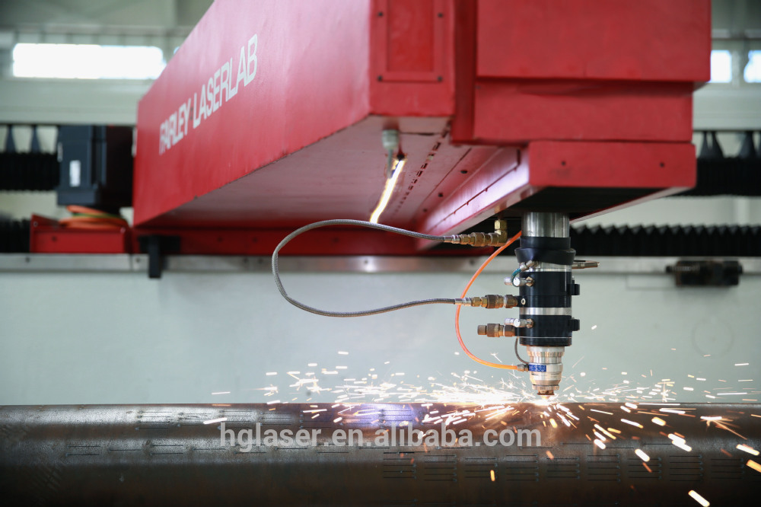

Cutting Head and Nozzle
/Customized Bifocal Laser Head(5 inch and 7.5 inch);
/Laser head can detect pipe on-contact before cutting and automatically position when cutting to match position change;
/Anti-collision all-around auto reset cutting head.

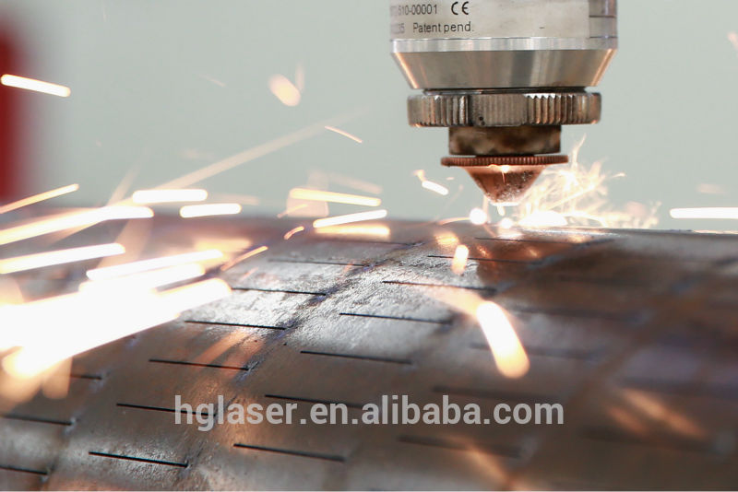

Rotation Axis

/Support position adjusted according to the pipe diameter;

/Max, pipe length: 12m Max, pipe diameter:240mm;

/Rotating clamp adopt double chuck structure to avoid the pipe not being vertical and thermal deformation in processing;

/Varying pitch worm gear is adopted to effectively achieve mechanical wear compensation.

Technical Parameters

model | profile
Processing Area | 12000×1500(mm)
Laser Power | 4000W
Customized Laser Cutting Head | 5 inch and 7.5 inch
PRECITEC Sensor | High Voltage 25kg/cm2
CNC System | Beckhoff/611D 1FT6 Motor
Operation System | Windows XP
Max. Pipe Length | 12m
Max. Wall Thickness | 20mm
Pipe Diameter | 50mm to 210mm
Kerf Quantity | Any
Kerf Width | 0.18-6mm(±0.03mm)
Kerf Type | Parallel/Crisscross/Spiral
X/Y/Z Driver Axis | Y/Z: Ball Screw X:Gear and Rack
X Axis | Fast-moving Speed | 50m/min
 | Stroke | 2000mm
 | Position Accuracy | +/-0.03mm
 | Repeatability | 0.03mm
 | Resolution | 0.001mm
Y Axis | Fast-moving Speed | 30m/min
 | Stroke | 1500mm
 | Position Accuracy | +/-0.03mm
 | Repeatability | 0.03mm
 | Resolution | 0.001mm
Z Axis | Stroke | 100mm
 | Resolution | 0.001mm
A Axis | Position Accuracy | +/-0.05°
 | Area | Max. Pipe Length:12m Diameter:240mm
 | Repeatability | +/-0.01°
 | Min Resolution | 0.001°
 | Rotary Speed | 7200°/min

Sample
